

***GROUP MEMBERS:* Student1364052 NIMRAH KHALID &**

**Student1367274 SHEHZONIA FATIMA**

Contents

***CERTIFICATE OF COMPLETION*** 4

**ACKNOWLEDGEMENT** 5

**PROJECT SYNOPSIS** 6

***PROPOSED SYSYTEM:*** 7

***FLOWCHART:*** 8

8

***Functional Requirement*** 9

***Problem Statement:*** 10

***Hardware and Software Requirements*** 11

**Hardware** 11

**Software** 11

***Website Features*** 12

**USER’S GUIDE** 13

**HOMEPAGE(landing page)** 13

**CONTACT US** 13

**ABOUT US** 14

**SLIDES** 14

**GALLERY** 16

16

**FOUNDATION** 16

**SAFETY COMES FIRST** 17

**OTHER FACILITIES** 17

Lockers 17

Separate Pools 18

Restrooms And Changing Areas 18

18

**FOOD ZONE** 19

**LOCATION MAP** 20

DEVELOPER’S GUIDE 20

CDN’s: 20

FOOD ZONE: 21

OTHER FACILITIES: 21

GALLERY: 22

We have given section there contains nine images of slides. 22

CONTACT US: 22

LOCATION: 22

# ***CERTIFICATE OF COMPLETION***

This is to clarify that **Nimrah Khalid** and **Shehzonia Fatima** have successfully completed their ACCP Semester 1 E-Project.

Submitted to Aptech Computer Education on

July 28th,2022

# ***ACKNOWLEDGEMENT***

First of all we would like to thank Almighty Allah for giving us strength and ability to complete this project.

And then, we would like to express our special thanks of gratitude to our teacher **Sir Faizan Sabir** who guided us on the project *Sanjalika Water Park*, which also helped us in doing a lot of new learning and we came to know about so many new things we are really thankful to him.

We are highly thankful to **Sir Faizan Sabir** for his guidance and constant supervision as well as for providing necessary information regarding the project & also for his support in completing the project.

We earnestly hope that this project will provide all the necessary information required by the user to fulfill his/her inspiration. However, suggestion and Feedbacks for improvements will be thankfully welcomed & acknowledged*.*

# ***PROJECT SYNOPSIS***

Sanjalika Water Park is one of the best place for family outings, it provides peaceful environment. Due to rapid development in internet field, the park decides to launch a website where people will get all the information about the park.

# ***PROPOSED SYSYTEM:***

To overcome the problems stated, it has been proposed to develop a website which includes their main slides and the views of the waterpark through which they want to attract more customers. So in this way the corporation can easily evolve and expand their business overseas to generate more sales and bring the corporation under the country or the world’s top 30.

# ***FLOWCHART:***

**SANJALIKA WATERPARK**

**HOME**

**PARK INFO**

**WATERPARK**

**FOUNDATION**

**SAFETY**

**SLIDES**

**PLAN VISIT**

**FOOD ZONE**

**PARKING**

**LODGING**

**FACILITIES**

**GALLERY**

**BLOG**

**ABOUT US**

**CONTACT US**

**LOCATIONS**

**VISITORS INFO**

# 

**VISITING HOURS**

**FULL DAY TIC.**

**SEASONAL TIC.**

**BOOKING**

**TICKETS**

# 

# ***Functional Requirement***

1. Home Page
2. Foundation
3. Slides
4. Food Zone
5. Other Facilities
6. Lockers
7. Separate Pools
8. Restrooms And Changing Rooms
9. Booking
10. Gallery
11. Contact Us
12. About Us
13. Location

# 

# ***Problem Statement:***

Sanjalika Water Park is definitely an ultimate and out of the world source of entertainment. Decorated by mermaids, other statues, the Sanjalika Water Park has largest cave and swimming pool area of modern technology a kind of place for thrills and fun. At Sanjalika Water park there is lot of water rides which are very exciting and thrilling. We need to develop a website of ‘SANJALIKA WATER PARK.

# ***Hardware and Software Requirements***

## **Hardware**

* A minimum computer system that will help you access all the tools in the courses is a Pentium 166 or better
* 64 Megabytes of RAM or better

## **Software**

* Notepad/HTML editor
* Dreamweaver
* IE 5.0/ Netscape 6.0

# 

# ***Website Features***

This Website ,Sanjalika Waterpark houses almost all of the content that a person leading to a customer wants to see in a waterpark that they want to go to. The features of this website allows a customer to see all their slides and their features, prior booking their tickets, see the snacks and beverages the various restaurants or food stalls have to offer, see the current time, see the parks visiting hours , other facilities and much more.

They can even contact us if they have any queries.

# **USER’S GUIDE**

## **HOMEPAGE(landing page)**

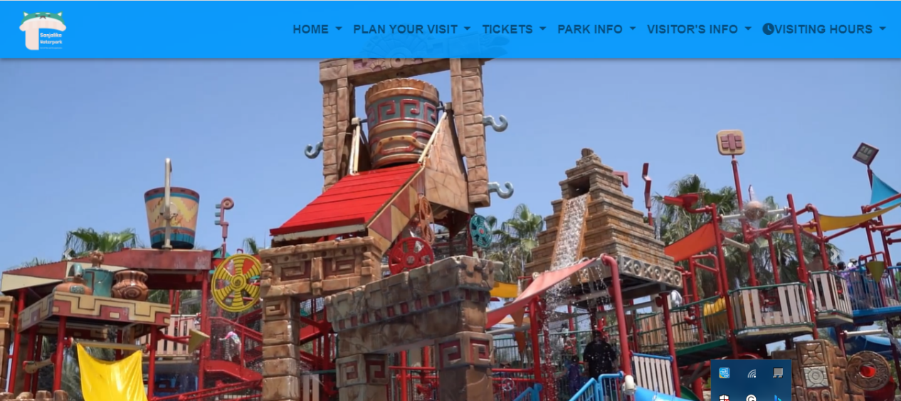

## **CONTACT US**

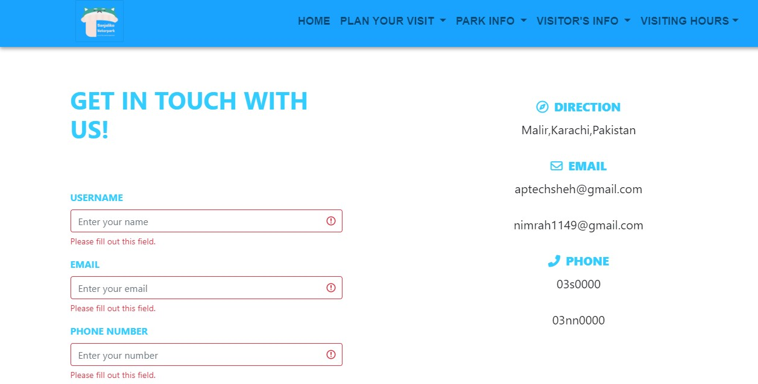

## **ABOUT US**

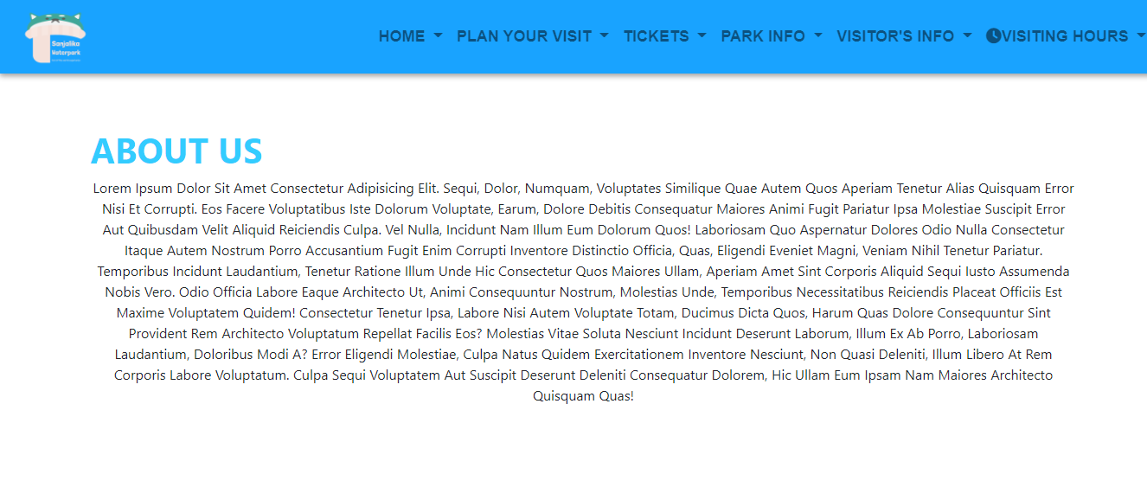

## **SLIDES**

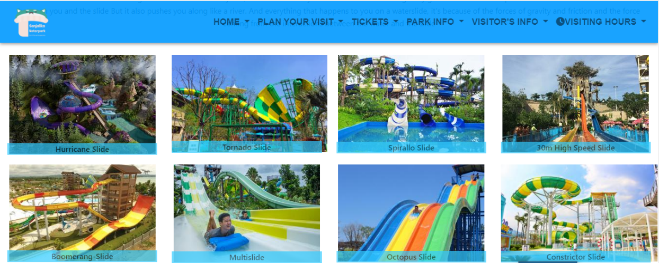

**BOOKING**

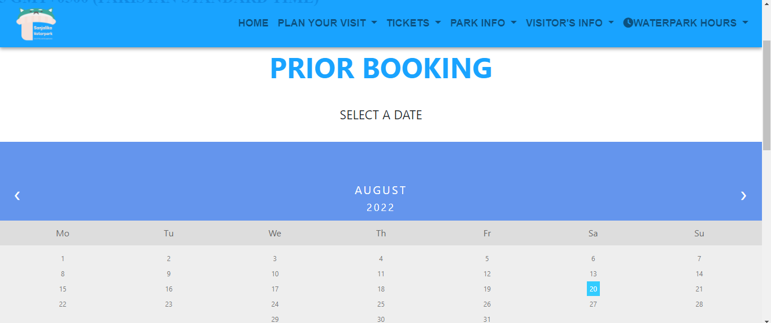

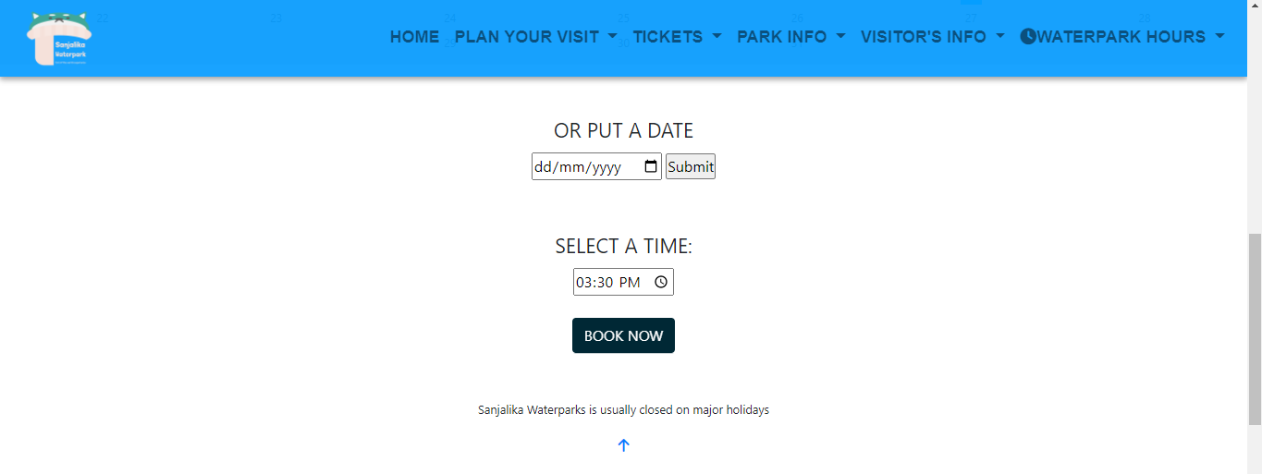

## **GALLERY**

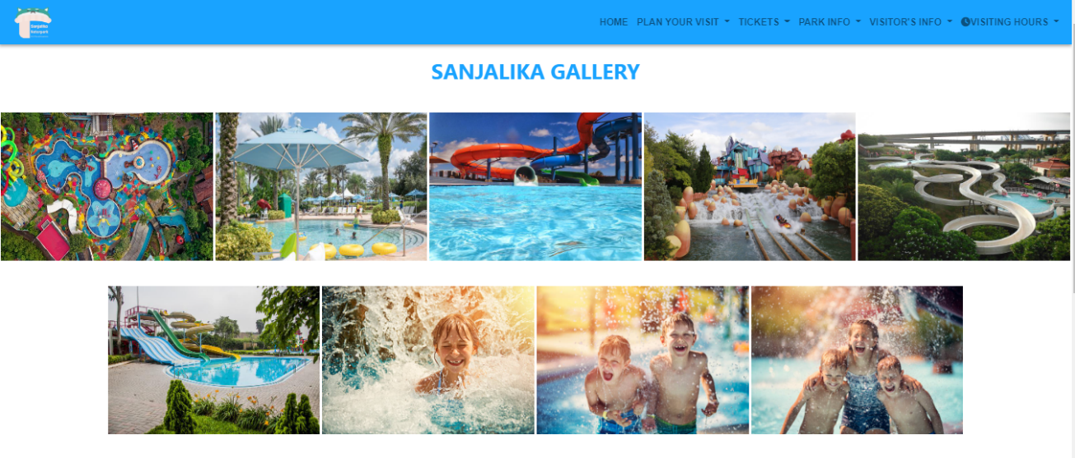

## **FOUNDATION**

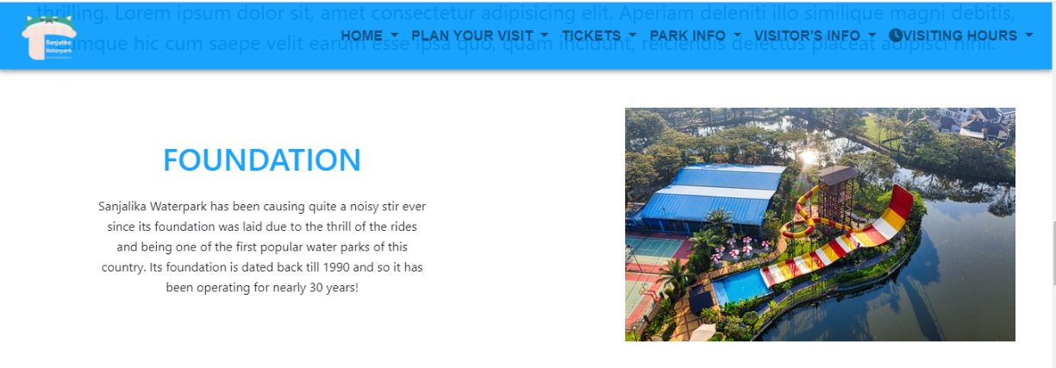

## **SAFETY COMES FIRST**

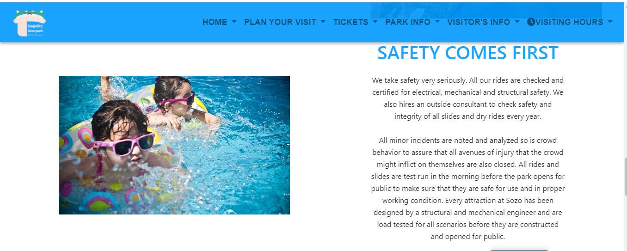

## **OTHER FACILITIES**

### Lockers

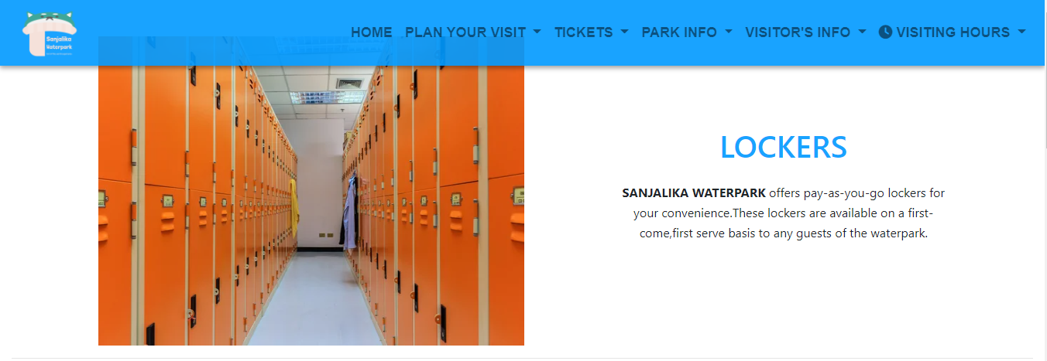

### Separate Pools

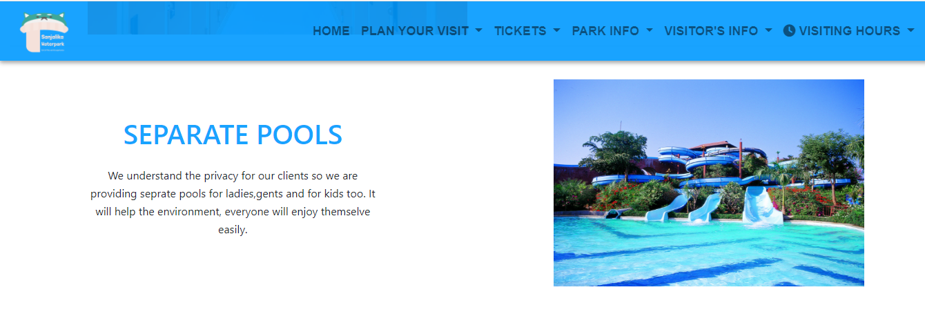

### Restrooms And Changing Areas

### 

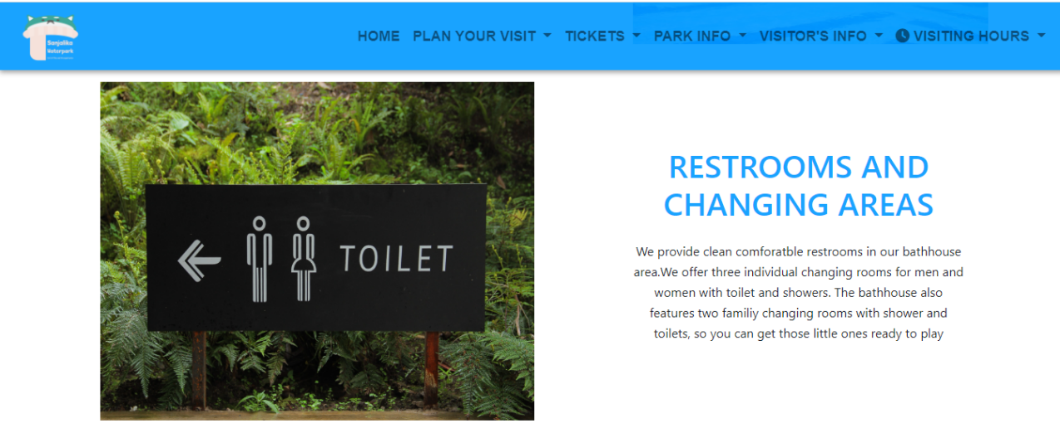

## **FOOD ZONE**

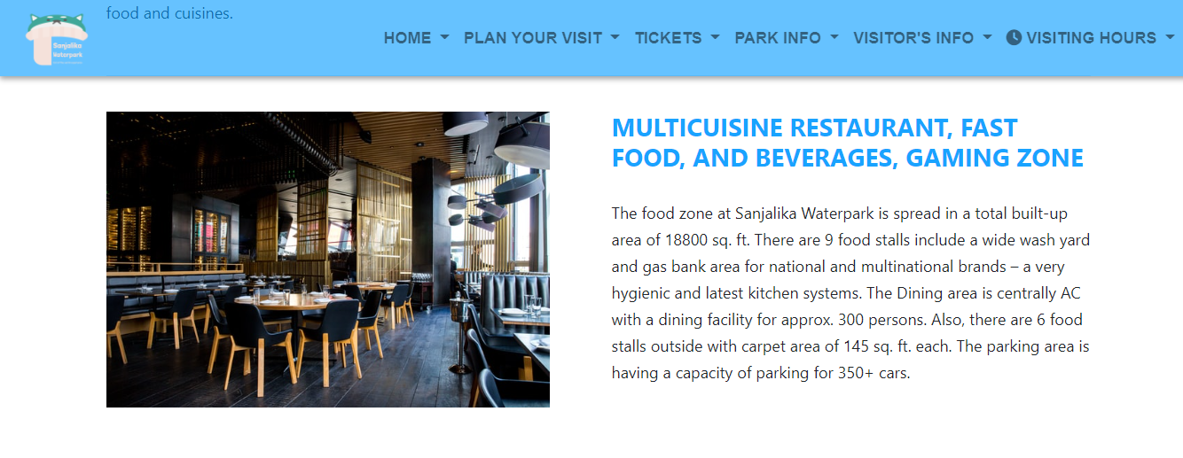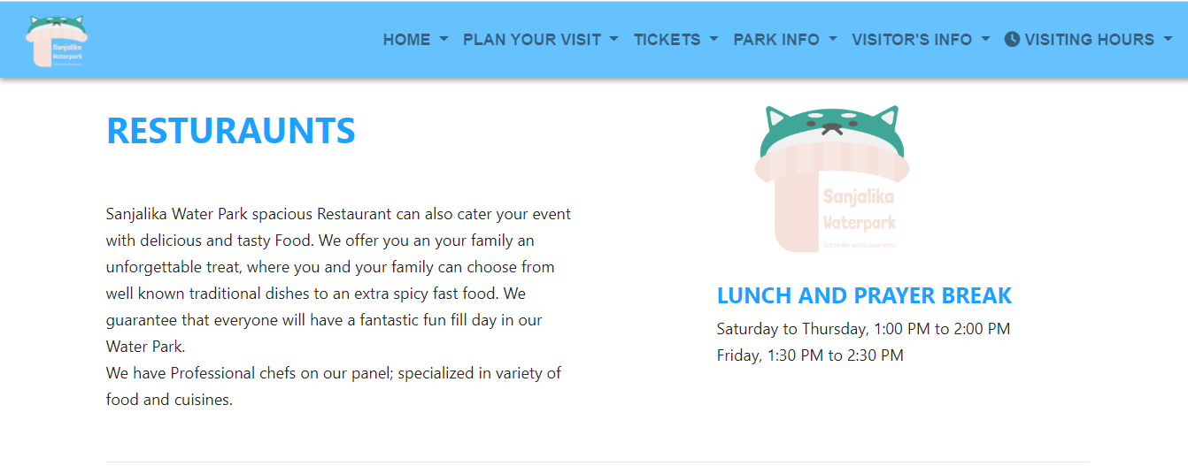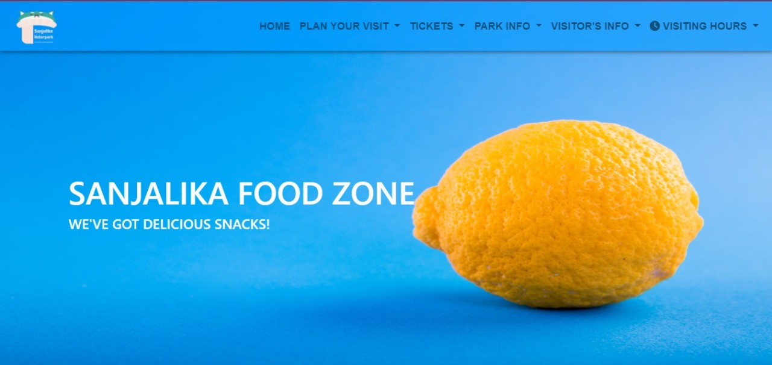

## **LOCATION MAP**

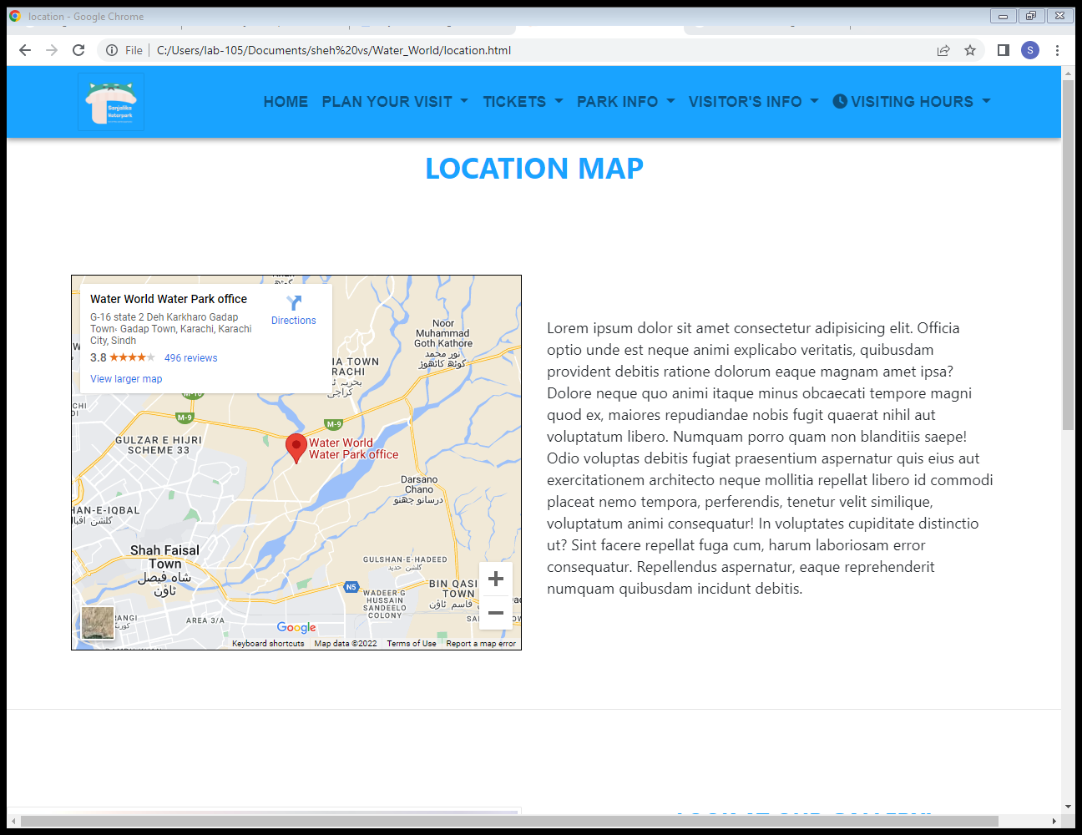

# ***DEVELOPER’S GUIDE***

We needed to develop a website of a waterpark named SANJALIKA WATER PARK. This is a guide for developers on how this website has been created and everything the next developer needs to know to make changes or study the website.

## CDN’s:

Almost all of the work has been done using bootstrap 4.

HOMEPAGE(Landing Page):

We have given navbar at the top of the homepage which includes home, plan your visit, tickets, park info, visitor’s info, visiting hours. All these tabs have dropdown lists. After that we have given carousel which includes 6 slides. Below the curosel there are three sections given those includes images and brief information about SANJALIKA WATER PARK, foundation and safety comes first heading. In last we have given slides with images you will further see the information about each slide by clicking on them.

## FOOD ZONE:

After navbar we have given an image as a banner. Below the banner there are divs those include images and content about a restaurant , we have given lunch and prayer break timing also at the food zone page. In the end we put our well known food partners.

## OTHER FACILITIES:

There we have given three sections each sections include a image and content those are lockers, separate pools and restrooms and changing rooms.

BOOKING:

It contains a form containing calender here we give a button for booking feature.

## GALLERY:

## We have given section there contains nine images of slides.

## CONTACT US:

We have given a form in contact us page. On the other hand we have given our email addresses and contact numbers.

## LOCATION:

Here we gave the park location map.